**Restaurant Point of Sale C# WPF MS-SQL Edition**

Contents

Requirement 2

Username/password 2

User Manual 2

Developer Shortcuts 3

Touch Keyboard (How to disable keyboard) 3

Notifications 3

Dashboard Icon 3

Connection String 4

How to open Project 5

Video Tutorial 5

Video Tutorial Version -2 5

How to create Setup.exe file 5

Manual Process 5

Customer Display or Pole Display 5

How to Setup Database Script or How to import SQL Database script in SQL server 5

How to set your Receipt format 6

How to fix Error (if occur) 7

Install Reportviewer.exe (If invoice will not display) 7

How to Change Sales Register Style 9

How to Change Resulation/Layout 10

Support 12

Dynamicsoft 12

Requirement  
=================  
.NET Framework 4.5, Visual Studio 2013 - up to  
OS: Windows 7, 8, 8.1, 10 - up to

Username/password  
====================  
admin/admin  
mn/mn  
sa/sa

**Rest POS - Restaurant Point of Sale WPF Application** Used tools:   
Microsoft Visual Studio Professional 2013 Version 12.0.21005.1  
Microsoft .NET Framework Version 4.6.01586  
Microsoft SQL Server 2008 Management Studio 10.0.1600.22

Copyright © 2018

Developed by: [DynamicSoft](https://codecanyon.net/user/dynamicsoft)  
Contact: citkar@live.com

User ManualClick on Help icon in the Application header menu

# Developer Shortcuts

## Touch Keyboard (How to disable keyboard)

Keyboard/TouchScreenKeyboard.cs // Class file  
Themes/Generic.xaml // Design of Keyboard.

xmlns:k="clr-namespace:RestPOS.Keyboard" //Reference/library in XAML page inside Window tag

k:TouchScreenKeyboard.TouchScreenKeyboard="true" //Use this XAML code inside the textbox  
k:TouchScreenKeyboard.TouchScreenKeyboard="false" // To remove keyboard or remove the tag

**Example:**  
<TextBox **k:TouchScreenKeyboard.TouchScreenKeyboard="true"** HorizontalAlignment="Left" Height="24" Margin="30,183,0,0" TextWrapping="Wrap" VerticalAlignment="Top" Width="278"/>

## Notifications

Public variable

private const double topOffset = 180;

private const double leftOffset = 780;

readonly GrowlNotifiactions growlNotifications = new GrowlNotifiactions();

// Notification Display position in WPF Form/ Monitor Screen  
growlNotifications.Top = SystemParameters.WorkArea.Top + topOffset;  
growlNotifications.Left = SystemParameters.WorkArea.Left + SystemParameters.WorkArea.Width - leftOffset;

**Example:**growlNotifications.AddNotification(new Notification { Title = "Wow ", Message = "Transaction has been sucessfully done", ImageUrl = "pack://application:,,,/Notifications/notification-icon.png" });

Dashboard Iconwe have used svg icon into dashboard button. You can change as your choice. Go to search and find svg icon code and Replace to same line what exactly u willing to change.

Example:   
<Canvas Width="80" Height="85">  
 <Path Width="80" Height="80" Canvas.Left="0" Canvas.Top="0" Stretch="Fill" StrokeThickness="1" StrokeLineJoin="Round" Fill="WhiteSmoke"

Data="**M 4 3 C 3.4777778 Your svg code z**"/>

</Canvas>

## Connection String

DataAccess.cs // Class file - Database connection class file

// Connection String for SQLite Database

static string _ConnectionString = @"Data Source=RestPOS.db; Version=3;New=False;Compress=True";

//// Built-in class

// SQLiteConnection

// SQLiteCommand

// SQLiteDataAdapter

//Its absolute Connection String for MS SQL Server

static string _ConnectionString = "Data Source=(local);Initial Catalog=RestPOS; User ID=aposdb;Password=aposdb!";

//// Built-in class

// SqlConnection

// SqlCommand

// SqlDataAdapter

// Mysql Database

static string _ConnectionString = "server=localhost; database=RestPOS; uid=root; PASSWORD=";

//// Built-in class

// MySqlConnection

// MySqlCommand

// MySqlDataAdapter

// MS Access Database   
static string _ConnectionString = @"Provider=Microsoft.Jet.OLEDB.4.0; Data Source=|DataDirectory|\RestPOS; Jet OLEDB:Database Password=16ad-smpas;";

//// Built-in class

// OleDbConnection

// OleDbCommand

// OleDbDataAdapter

// MS Compact Database

static string _ConnectionString = "Data Source=|DataDirectory|RestPOS.sdf; Persist Security Info=False;";

//// Built-in class

// SqlCeConnection

// SQlCeCommand

// SqlCeDataAdapter

// Use for Adv_POS.exe.config file / Custom file

static string _ConnectionString = supershop.Properties.Settings.Default.psodbConnectionString1;

## How to open Project

<https://www.youtube.com/watch?v=AcOoGkG0m8I>

## Video Tutorial

<https://www.youtube.com/watch?v=ua0HyBdjNmY>

Video Tutorial Version -2   
<https://www.youtube.com/watch?v=bVxvAaHUSEw>

## How to create Setup.exe file

How to make installer from source code  
=============================================

Step 1: Please create a new project. (Do not create installer file/project in same project.)

How to create a setup file in Visual Studio [Official video tutorial]   
<https://www.youtube.com/watch?v=4ca8HPnY8hE>

Manual Process  
===================  
If you need for client

Please Copy whole \RestPOS\bin --> Debug folder and make a shortcut of **RestPOS.exe** file -- (not this one RestPOS.exe.config)

Paste to desktop or anywhere where do you want. And make a zip file

*Do not create installer file/project in same project.*

## Customer Display or Pole Display

Uncomment Line 491 to 503 in **SalesRegister.xaml.cs** file

# How to Setup Database Script or How to import SQL Database script in SQL server

Click -> [Please Check the Database script import Documentation](../DatabaseScript/How%20to%20import%20Database%20Script%20into%20SQL%20Server.docx)    
or Check this video Example: [[Youtube] 🡪 How to import sql database script](https://www.youtube.com/watch?v=yBhNP9Z23U4)

How to set your Receipt format   
Open **ReceiptPrint.xaml.cs**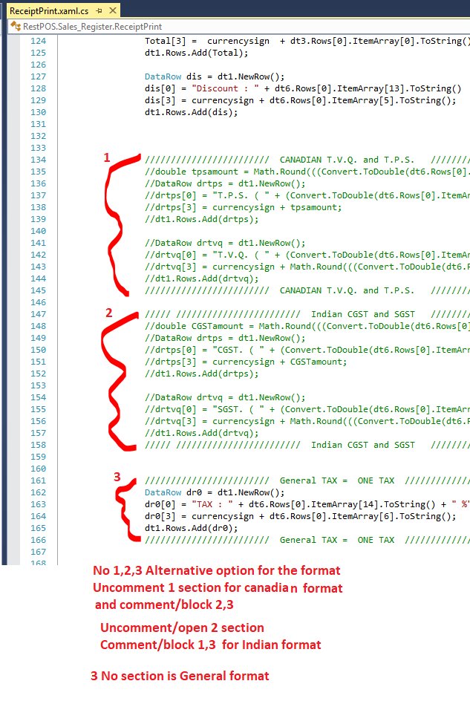

## How to fix Error (if occur)

If you face Debugging error

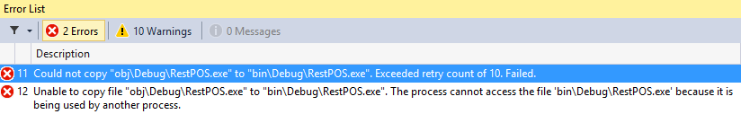

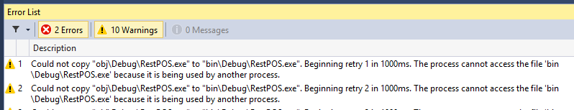

Step1: Go to 🡪 \bin\Debug and rename **RestPOS.exe** to 0.exe (Not this file RestPOS.exe.config)

Step2: Run or compile again or Press F6 and F5

## Install Reportviewer.exe (If invoice will not display)

If something occur please install Reportviewer.exe

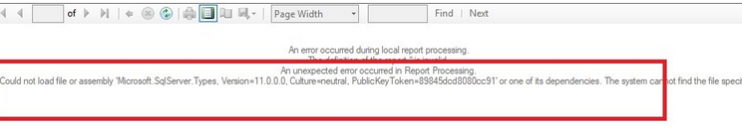

If occur this error 🡪 “Could not load file or assembly 'Microsoft.ReportViewer.Common, Version=11.0.0.0, Culture=neutral,” or Microsoft.ReportViewer.WinForms, Version=11.0.0.0,

**Solution**: please install **Reportviewer.exe**

1. <https://download.microsoft.com/download/F/B/7/FB728406-A1EE-4AB5-9C56-74EB8BDDF2FF/ReportViewer.msi>
2. or <https://1drv.ms/u/s!ApqzQIEDs_C5jdIlAOEX_VDyl2tFng>

Or 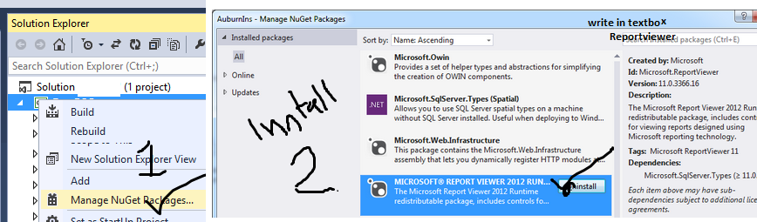

2. **Error** Messages -> “could not load file or assembly 'microsoft.sqlserver.types version=11.0.0”



**Solution**: Right click on project file solution explorer -> select Nuget packages -> install microsoft.sqlserver.types

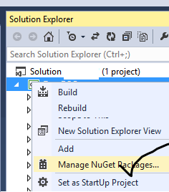

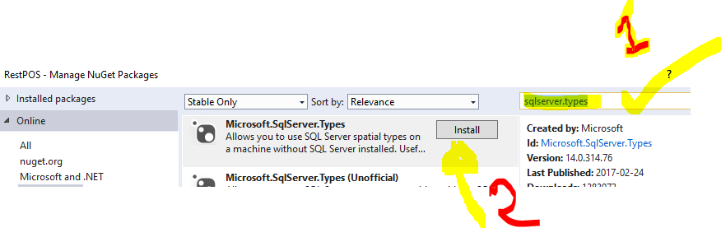

# How to Change Sales Register Style

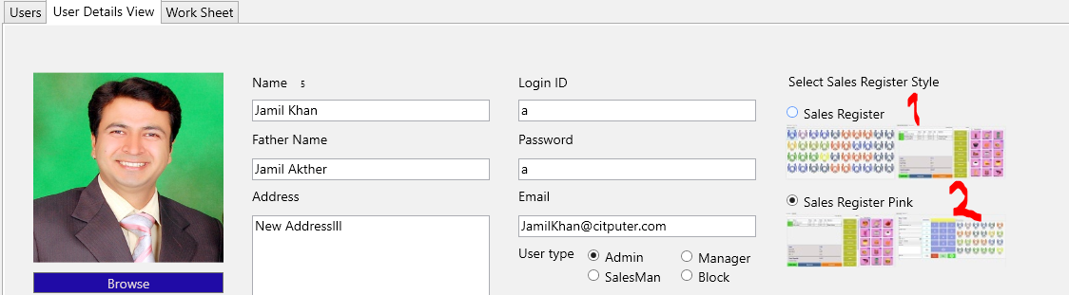

1. SR: Select table from Table Layout and add item to Cart 🡪 complete transaction.
2. SR-Pink: Add item to cart 🡪 Select table from Table Layout 🡪 complete transaction.

# How to Change Resulation/Layout

This POS is by default resulation is 1366 * 766

To change please follow below steps

**Display resolution 1024x768 for 12inch screen**

1. Change page width in SalesRegister.xaml  and SalesRegisterPink.xaml page   
   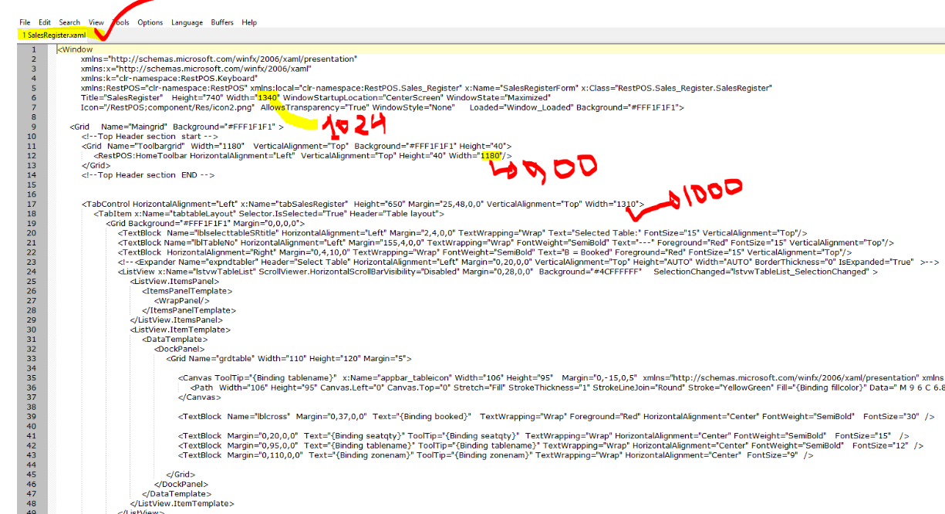  
   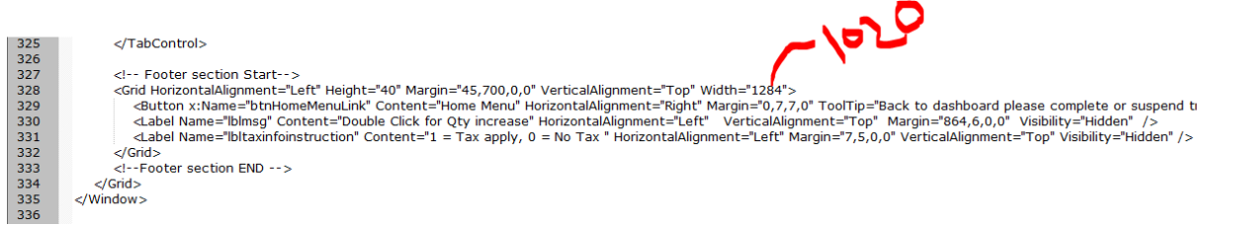

OR Open with design Mode and Drag and Resize.

1. Edit **Login.xaml** file
2. 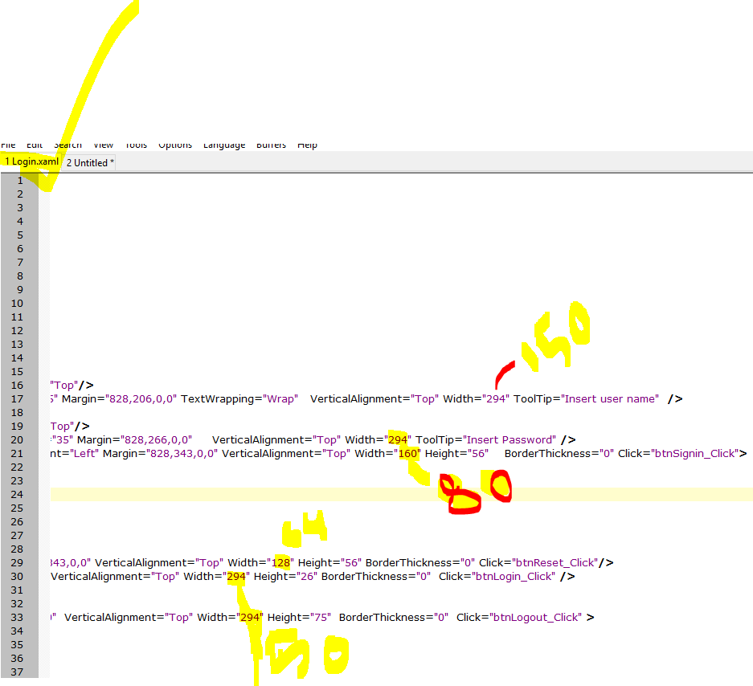

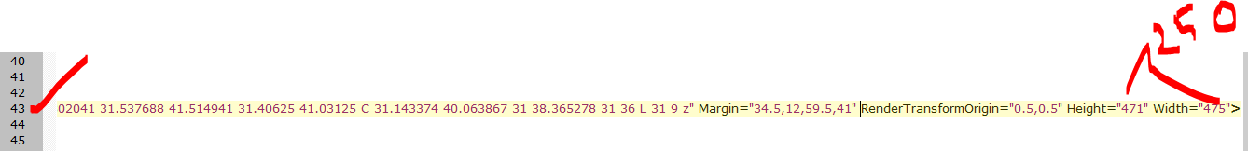

Support  
================  
Email to [citkar@live.com](mailto:citkar@live.com)  
Subject: Restaurant-POS-System WPF-SQL

**Mention your**Buyer Envato Username:   
Purchase code:   
Order Invoice no:   
Purchase date:   
Ore leave a message <https://codecanyon.net/user/dynamicsoft>

Please don’t forget to Rate us:

[**http://codecanyon.net/downloads**](http://codecanyon.net/downloads)

## [Dynamicsoft](https://codecanyon.net/user/dynamicsoft)

<https://codecanyon.net/user/dynamicsoft>

**Video tutorial**

[How to hold order and recall resume order again in Restaurant POS software - Tutorial-1](https://www.youtube.com/watch?v=C2XrRY3WSY4)

[How to import SQL script and setup in Restaurant POS - Tutorial-2](https://www.youtube.com/watch?v=yBhNP9Z23U4)